**Machine Learning (ICP # 1)**

Question 1 The following is a list of 10 students ages: ages = [19, 22, 19, 24, 20, 25, 26, 24, 25, 24] • Sort the list and find the min and max age • Add the min age and the max age again to the list • Find the median age (one middle item or two middle items divided by two) • Find the average age (sum of all items divided by their number) • Find the range of the ages (max minus min)

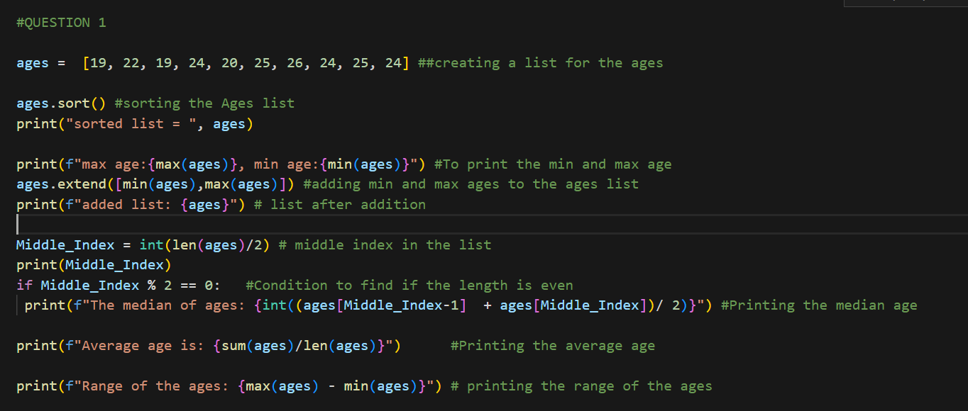

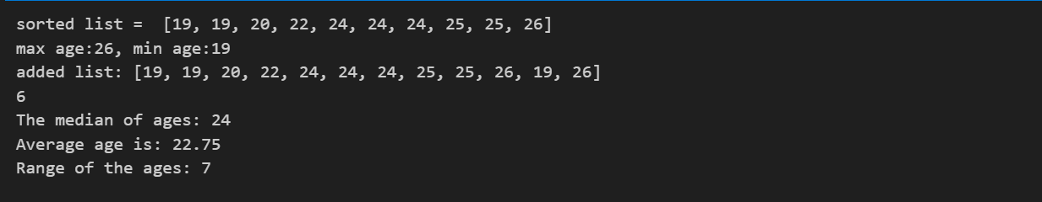

Question 2 • Create an empty dictionary called dog • Add name, color, breed, legs, age to the dog dictionary • Create a student dictionary and add first_name, last_name, gender, age, marital status, skills, country, city and address as keys for the dictionary • Get the length of the student dictionary • Get the value of skills and check the data type, it should be a list • Modify the skills values by adding one or two skills • Get the dictionary keys as a list • Get the dictionary values as a list

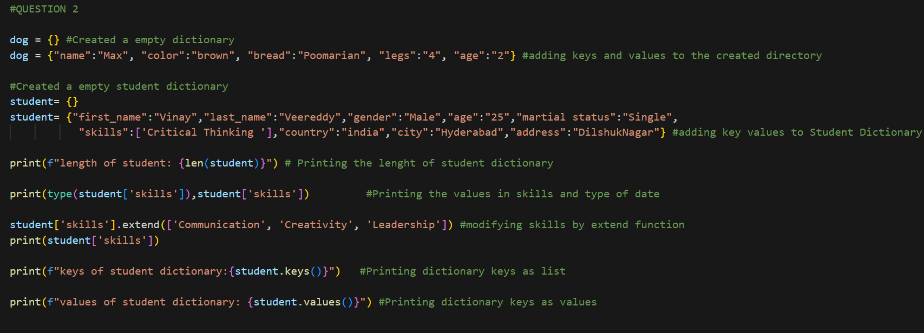



Question 3 • Create a tuple containing names of your sisters and your brothers (imaginary siblings are fine) • Join brothers and sisters tuples and assign it to siblings • How many siblings do you have? • Modify the siblings tuple and add the name of your father and mother and assign it to family_members

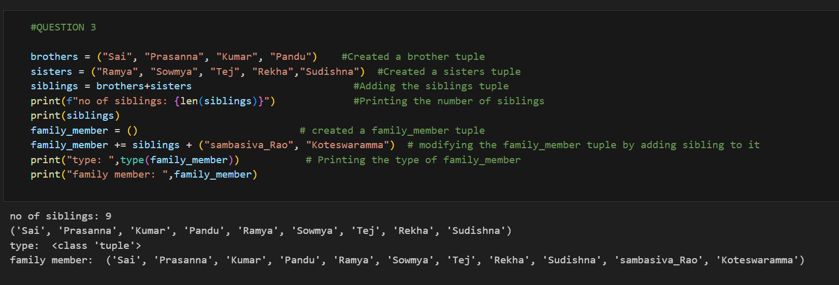

Question 4 it_companies = {'Facebook', 'Google', 'Microsoft', 'Apple', 'IBM', 'Oracle', 'Amazon'} A = {19, 22, 24, 20, 25, 26} B = {19, 22, 20, 25, 26, 24, 28, 27} age = [22, 19, 24, 25, 26, 24, 25, 24] • Find the length of the set it_companies • Add 'Twitter' to it_companies • Insert multiple IT companies at once to the set it_companies • Remove one of the companies from the set it_companies • What is the difference between remove and discard • Join A and B • Find A intersection B • Is A subset of B • Are A and B disjoint sets • Join A with B and B with A • What is the symmetric difference between A and B • Delete the sets completely • Convert the ages to a set and compare the length of the list and the set

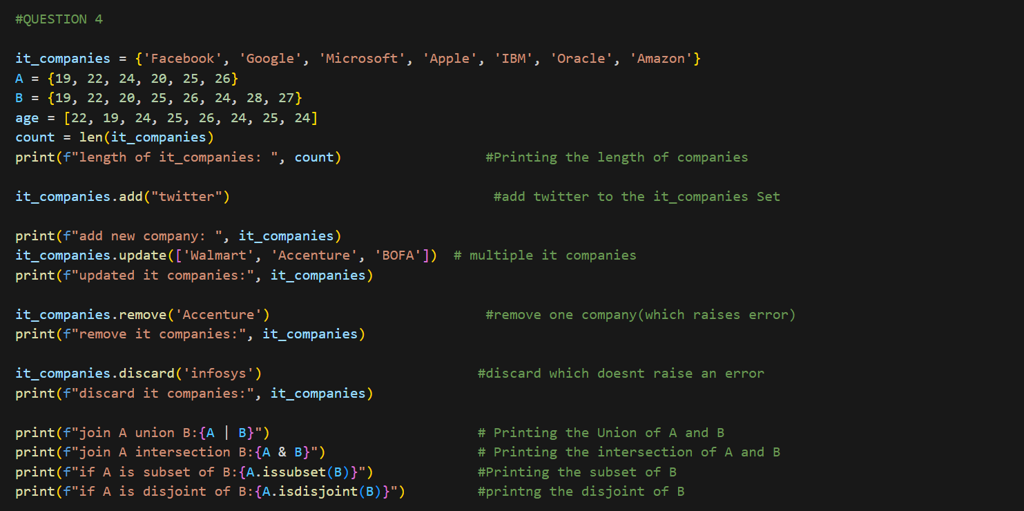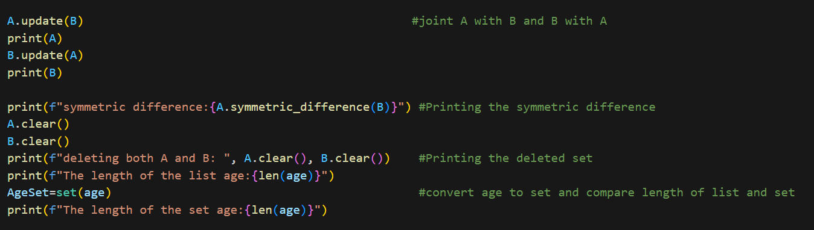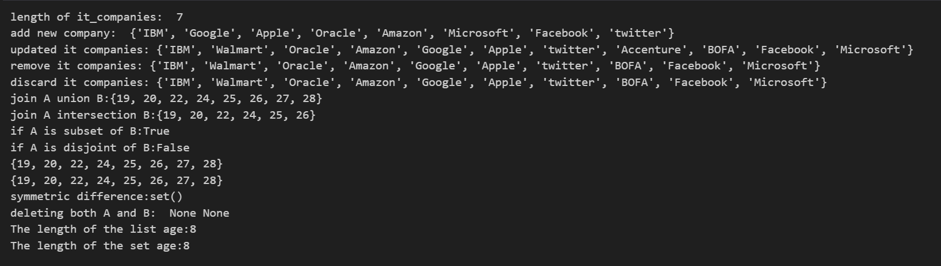

Question 5 The radius of a circle is 30 meters. • Calculate the area of a circle and assign the value to a variable name of _area_of_circle_ • Calculate the circumference of a circle and assign the value to a variable name of _circum_of_circle_ • Take radius as user input and calculate the area. 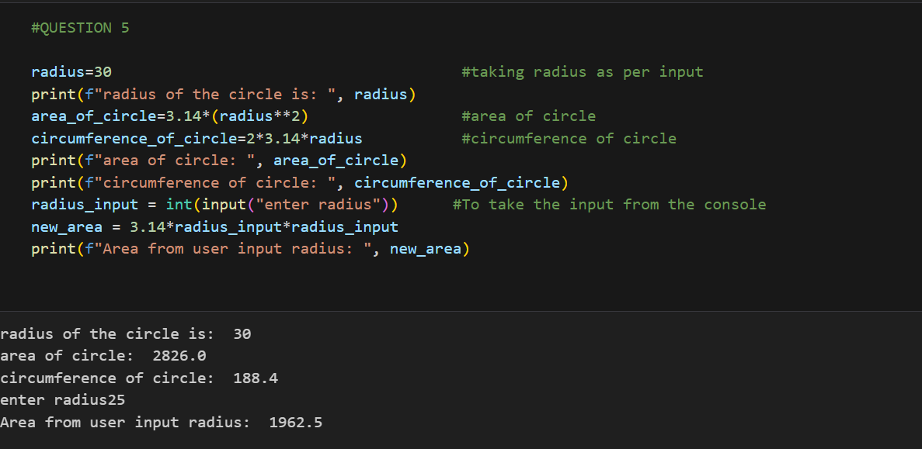

Question 6 “I am a teacher and I love to inspire and teach people” • How many unique words have been used in the sentence? Use the split methods and set to get the unique words.

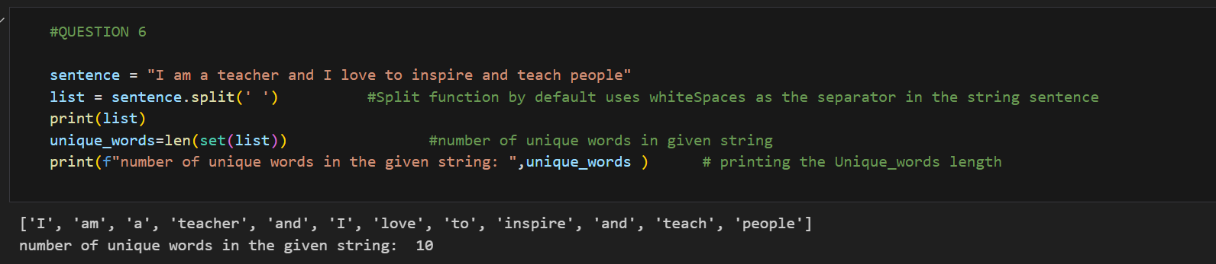

Question 7 Use a tab escape sequence to get the following lines. Name Age Country City Asabeneh 250 Finland Helsinki

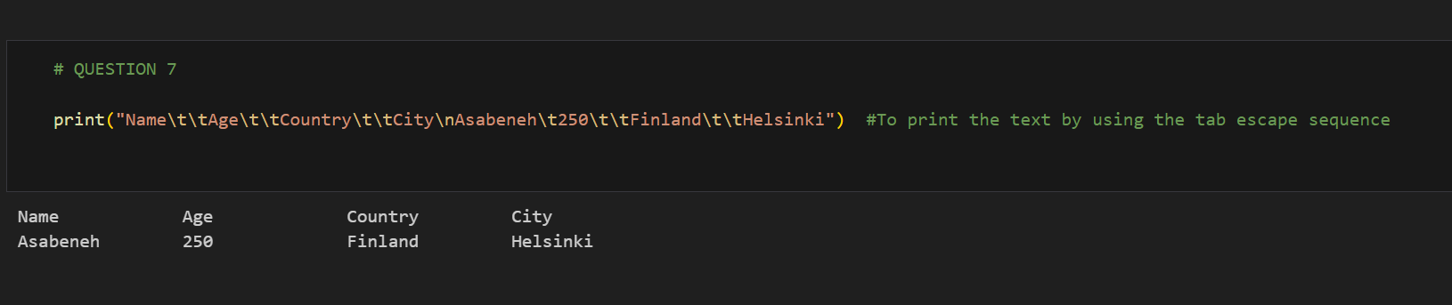

Question 8 Use the string formatting method to display the following: radius = 10 area = 3.14 * radius ** 2 “The area of a circle with radius 10 is 314 meters square.”

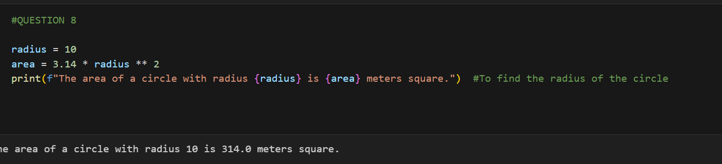

Question 9 Write a program, which reads weights (lbs.) of N students into a list and convert these weights to kilograms in a separate list using Loop. N: No of students (Read input from user) Ex: L1: [150, 155, 145, 148] Output: [68.03, 70.3, 65.77, 67.13]

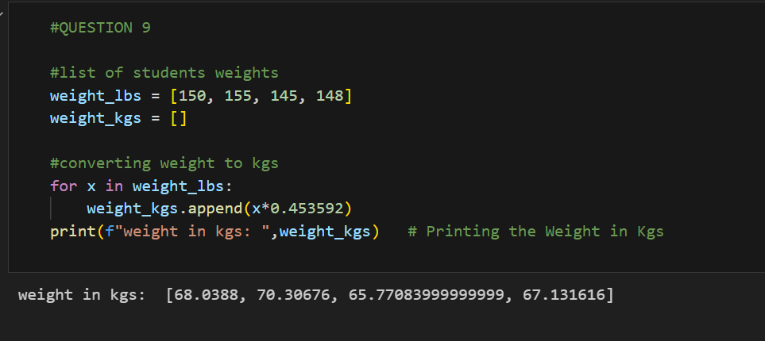

**Video Link :** https://vimeo.com/948980340/80d3566fe6?share=copy

**Git Link :** https://github.com/Arunkumarsilapuram/Assignment1